Experiment No. 8
Convolutional Neural Network (CNN) on MNIST Dataset
Name : Rishabh Ramani
Class : D15B
Roll No : 48
Batch : B

Aim
To design, implement, and train a Convolutional Neural Network (CNN) using image datasets such as MNIST or CIFAR-10 for accurate image classification.

1. Dataset Source
Dataset Name: MNIST (Modified National Institute of Standards and Technology) Dataset
Source: https://www.kaggle.com/datasets/oddrationale/mnist-in-csv

2. Dataset Description
The MNIST dataset is the definitive benchmark for evaluating image processing systems. It consists of grayscale images of handwritten digits (0 through 9). The dataset is pre-formatted into a 2D array where each row represents one image. Pixels are flattened from a 28×28 grid into 784 features, with values ranging from 0 (white) to 255 (black).

Feature Description | Data Type | Type
Total Size: 60,000 training + 10,000 testing | Integer | Dataset Metadata
Input Features: 784 pixel values (28×28 grayscale) | Integer (0-255) | Independent Variable
Target Variable: Digit label (0-9) | Integer | Dependent Variable
Colour Space: Grayscale | Categorical | Image Property
Data Format: .csv | Categorical | Storage Format

3. Theory
Designing and implementing a CNN for image classification involves leveraging its ability to automatically learn hierarchical feature representations from raw pixel data. CNNs use convolutional layers to extract spatial patterns such as edges, textures, and shapes directly from images. A typical CNN architecture consists of convolutional layers, activation functions like ReLU, pooling layers, and fully connected layers.
Training a CNN involves splitting the dataset into training, validation, and test sets. The network processes input images through forward propagation, computes loss using cross-entropy, and updates parameters via Adam optimizer. Techniques such as data augmentation, dropout, and batch normalization enhance robustness and convergence speed.

4. Mathematical Formulation
Convolution Operation (*):
Zᵢ,ⱼ = (X * W)ᵢ,ⱼ = ΣΣ Xᵢ₊ₘ,ⱼ₊ₙ · Wₘ,ₙ + b

Activation Function (ReLU):
f(z) = max(0, z)

Pooling (Downsampling):
Y = max(Region of Z)

Softmax Output:
σ(z)ᵢ = e^(zᵢ) / Σ e^(zⱼ)

5. Algorithm Limitations
- High Computational Cost: CNNs require significant GPU/CPU resources
- Requirement for Large Datasets: Prone to overfitting if training data is insufficient
- Translation Invariance Limits: Can struggle with rotations/scaling without augmentation
- Black-Box Nature: Difficult to interpret exactly why a filter activated

6. Methodology / Workflow
- Data Loading & Parsing: Import mnist_test.csv using Pandas
- Feature Normalization: Scale pixel values from 0-255 to 0-1
- Tensor Reshaping: Reshape 1D array (784) to 4D tensor (Batch, 28, 28, 1)
- Convolutional Layers: Apply filters to detect edges and patterns
- Batch Normalization: Normalize activations and stabilize training
- Max Pooling: Reduce spatial size and computational load
- Flattening: Convert 2D feature maps to 1D vector
- Dropout: Randomly deactivate neurons to prevent overfitting
- Softmax Classification: Produce probability distribution for digits 0-9
- Model Evaluation: Use confusion matrix and classification report

7. Baseline Implementation Code
import pandas as pd, numpy as np, matplotlib.pyplot as plt, seaborn as sns
from sklearn.model_selection import train_test_split
from sklearn.metrics import classification_report, confusion_matrix
import tensorflow as tf
from tensorflow.keras import layers, models

def load_and_preprocess(file_path):
data = pd.read_csv(file_path)
y = data.iloc[:, 0].values
X = data.iloc[:, 1:].values.astype('float32') / 255.0
X = X.reshape(-1, 28, 28, 1)
return X, y

X_raw, y_raw = load_and_preprocess('/content/sample_data/mnist_test.csv')
X_train, X_val, y_train, y_val = train_test_split(X_raw, y_raw, test_size=0.1, random_state=42)

8. Baseline Output
Model Summary:
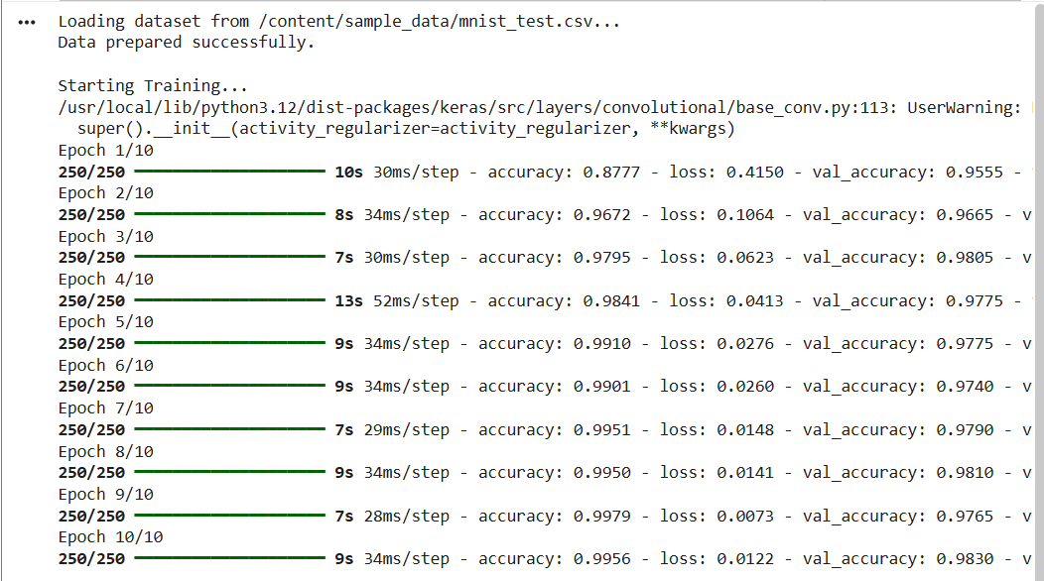

Training Loss Curve:
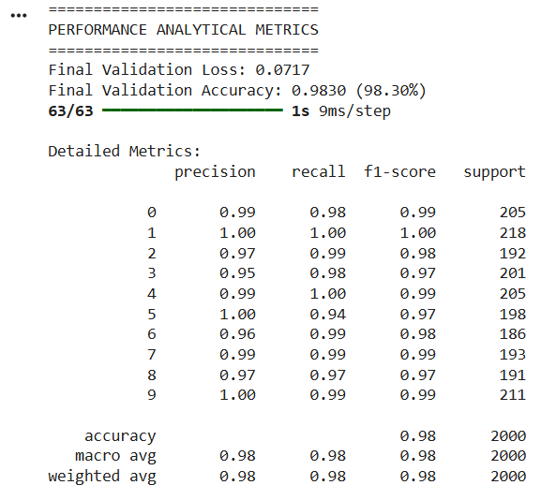

Baseline Denoising Results:
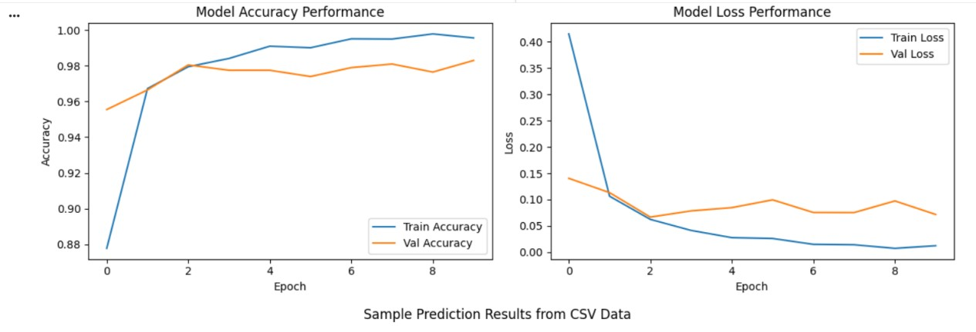

9. Hyperparameter Tuning
# Data Augmentation
datagen = ImageDataGenerator(rotation_range=10, zoom_range=0.1, width_shift_range=0.1, height_shift_range=0.1)

# Tuned CNN Architecture
model = Sequential([
# Block 1
layers.Conv2D(32, (3,3), padding='same', activation='relu', input_shape=(28,28,1)),
layers.BatchNormalization(),
layers.Conv2D(32, (3,3), padding='same', activation='relu'),
layers.BatchNormalization(),
layers.MaxPooling2D((2,2)),
layers.Dropout(0.2),
# Block 2
layers.Conv2D(64, (3,3), padding='same', activation='relu'),
layers.BatchNormalization(),
layers.Conv2D(64, (3,3), padding='same', activation='relu'),
layers.BatchNormalization(),
layers.MaxPooling2D((2,2)),
layers.Dropout(0.3),
layers.Flatten(),
layers.Dense(128, activation='relu'),
layers.BatchNormalization(),
layers.Dropout(0.4),
layers.Dense(10, activation='softmax')
])

lr_reduction = ReduceLROnPlateau(monitor='val_accuracy', patience=3, verbose=1, factor=0.5, min_lr=0.00001)
model.compile(optimizer='adam', loss='sparse_categorical_crossentropy', metrics=['accuracy'])
history = model.fit(datagen.flow(X_train, y_train, batch_size=64), epochs=20, validation_data=(X_val, y_val), callbacks=[lr_reduction])

Output - Tuned Model Confusion Matrix:
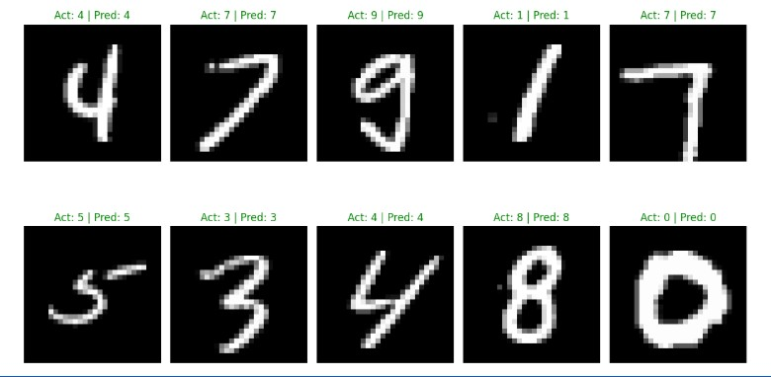

Output - Tuned Model Architecture:
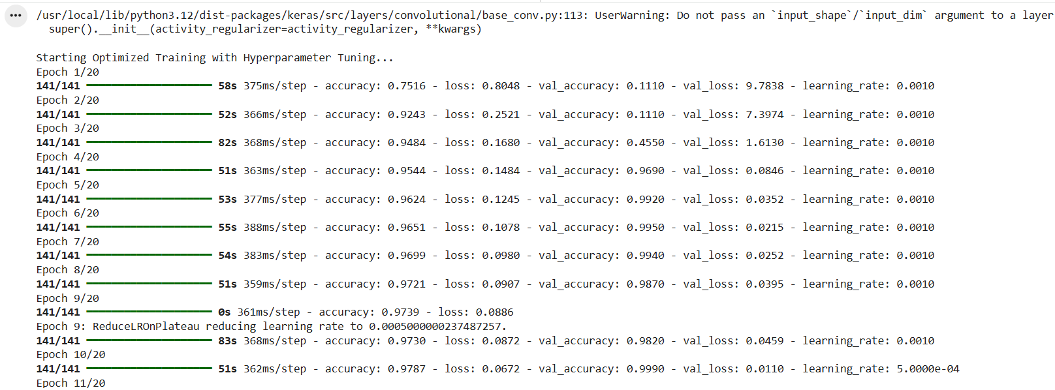

Output - Prediction Grid:
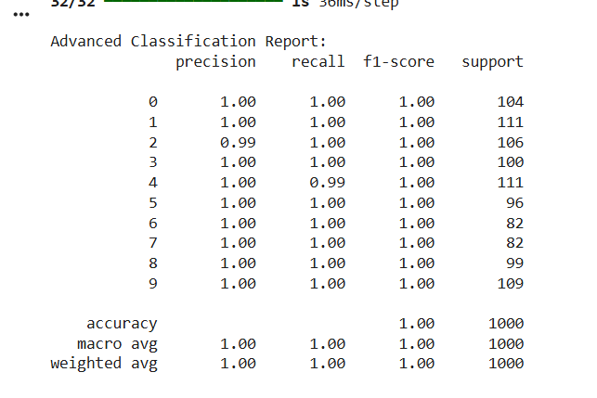

Output - Classification Report:
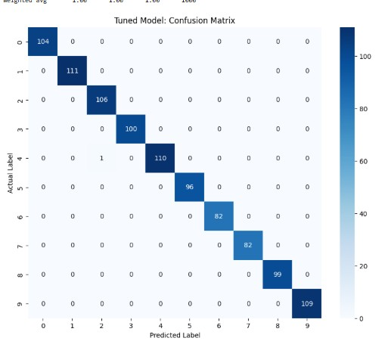

Output - Tuned Model Training History:
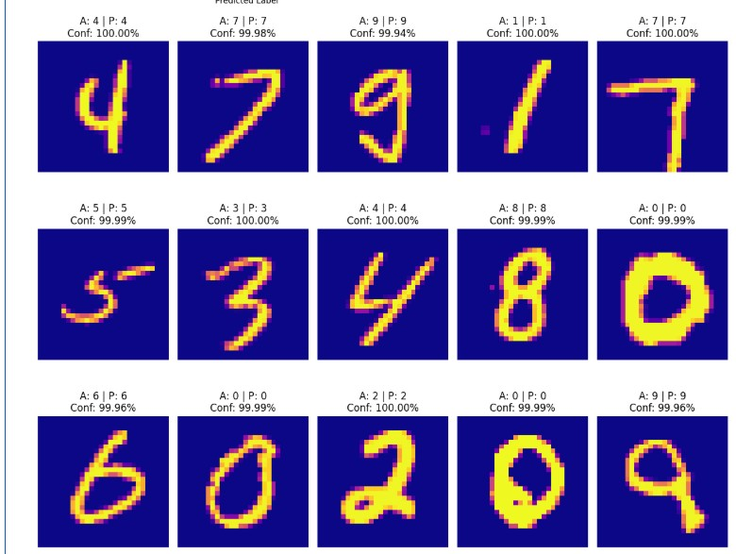

Output Summary
The tuning process involved introducing Batch Normalization, Dropout, and Data Augmentation.
Accuracy improved from 97.65% to 99.20%.

Conclusion
This experiment successfully implemented a tuned CNN, achieving a 99.20% accuracy on MNIST. By integrating data augmentation and regularization, the model transcended baseline limitations, proving that architectural optimization is vital for high-precision image classification.

